**Archery Madness**GDD

**Overview**

**Product Details**

* *Players*
  + *Single Player*
* *Genre*
  + *Carnival Game*
* *Platform*
  + *PC*
* *Outlets*
  + *Steam/Oculus Store*

**Summary**

An archery sideshow game you would see in a carnival; the player can choose from a variety of different arrows to knockout unique targets with different elements.

**Mechanics and Systems**

* Arrow shooting
  + Player arms an arrow and pulls back while holding a button/input to draw and releases the input to shoot.
  + OR
  + The system detects the handheld sensor positions, starts drawing when they are next to each other. Player clicks button to release.
* Arrow Types
  + 3 arrow types exist, Hammer, BroadHead and WaterBalloon
* Arrow Supply
  + Players have a limited supply of arrows.
  + The type of is affected by the availability of rare targets
    - Hammer- 10
    - Broad- 6
    - Balloon- 4
* Feedback
  + Barker
    - Sound
      * Barker will react to players actions
        + Taunt on failures
        + Cheer on successes
  + Bird (Target)
    - Visual
      * When hit, target goes down.
      * An affect will play.
        + Wood Bird: ?
        + Glass Armoured Bird: The Glass shatters
        + Fire Bird: Steam is seen when doused.
    - Sound
      * When hit a sound will play.
        + Wood Bird: A wooden thunk
        + Glass Armoured Bird: Glass shattering
        + Fire Bird: A hiss
  + Bow
    - Sound
      * When the bow is drawn/pulled the stretching of the string is heard.
      * When the string returns, a twang plays.
    - Haptic
      * When the bow is drawn/pulled, motors in the control increase in vibration closer to the shoulder.
      * When the string returns a subtle vibration is felt
  + Arrow
    - Visual
      * Arc appears for the player to see where they will hit
      * The Arrow will be seen shot
    - Sound
      * When the arrow is shot a Whoosh is heard
    - Haptic
      * A slight bump is felt when the arrow is picked up.
* Environmental Impairments
  + Water: Sprinklers activate to impede the players vision of the targets
  + Wind: Turbines/fans activate to change the direction of the arrow
    - There will be strips of paper or tassels to show the direction of the wind so the player can anticipate wind direction.
* Points
  + Very basic determined point system whereby the wooden birds are 5 pts, the next glass/armoured birds are 10 pts and the on-fire birds are 20 pts.

**Player Progression**

Target Movement and Pacing

After a set time (10 secs) the pace will increase, through sound (plays faster, music becomes hectic)

Type of birds will appear based on an assigned percentage.

* Wooden Birds: 60%
* Glass Birds: 50%
* Fire Birds: 40%
* The 1st phase targets will be on rails, they will move back and forth in a linear way.
* The 2nd phase targets will also be moving back and forth at a faster pace
* 3rd phase, all targets from the previous phases return, and move at an even faster pace
* Each phase adds another type of complexity after 10 secs.
  + Side targets
  + Side to side
  + Ceiling
  + Circular
  + Environmental
    - Sprinklers: water sprinkles so the player has a hard time seeing the target to hit
    - Fans: the wind will change the direction of the arrow

Arrow Display

When the player hits the start button, the arrows will bounce up from the container to show the player that new arrows are available.

The table will have 3 containers (Barrel/Quiver) for the different types of arrows.

The containers have a symbol to clearly show what the contained ammo will work against in the range.

* Hammer = a bird being knocked over by the flathead arrow
* Armour = a glass bird being shatter by the broadhead
* Balloon = a fire being put out by water

Each of these images would have a number in the middle to represent how many arrows are currently left to be shot for each arrow type.

The visuals should try to also reinforce the current number of arrows left available.

When the player has shot all the arrows, the game is over. The start button changes to a “Replay” button and the players score is announced/heckled by the barker.

**Pillars**

**Unique Selling Points**

**Target Market**

The target audience of this product is broad. It consists of people (families and individuals) who might typically attend a circus, fair or exhibition. To ensure current industry safety and age guidelines are met developers are to assume children are aged 13+.

Users must be able to wear the desired platform (Oculus Go headset / Google cardboard) and must be able to use any auxiliary hardware to interact with the product (eg Oculus Go controller or Google cardboard, virtual menus).

**Persona**

**Game Loops**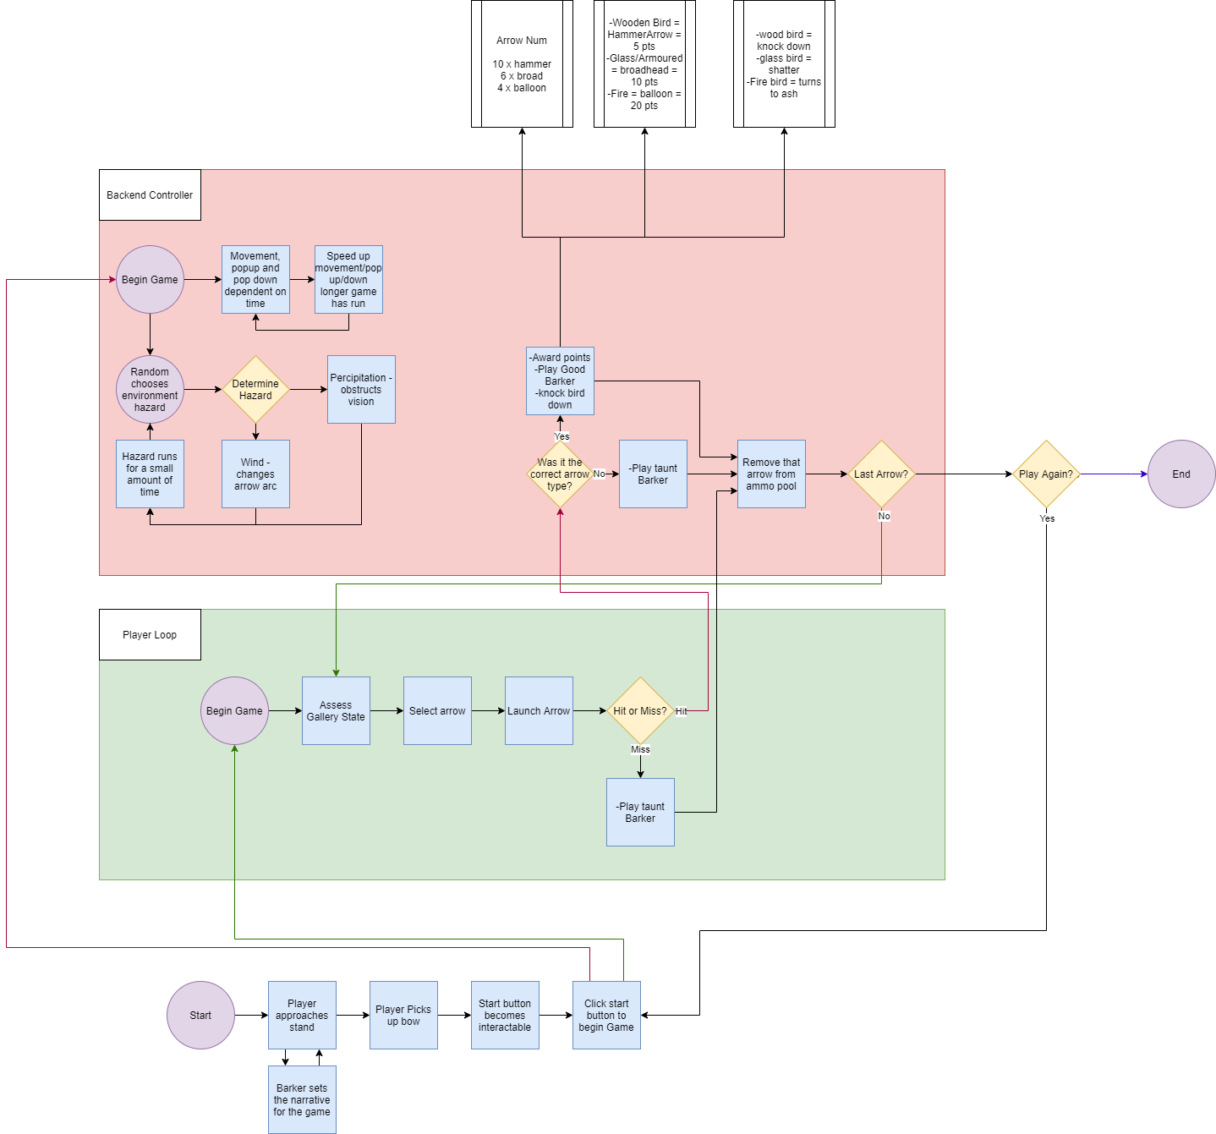

**Controls**

TBD – Must research VR headset we will be using for the possible use of controls.

* It will be around the players hand movements as if they were firing an actual bow to add authenticity and feel to the game, as well as use full advantage of VR capabilities.
* Player movement is limited to being locked at the table or firing area, they will be able to look around.
* Can use controls to draw the bow and fire with the buttons available at the hand controls

**Key Characters**

* Player
  + Player is a visitor to the carnival games and is keen to test out their archery skills against changing targets.
* Barker
  + Essentially an announcer of the players success or fails, will at times antagonise the player if they miss or hit with the wrong arrow.
  + Will encourage the player if the player hits and succeeds.
  + Adds character and theme to the carnival feel of the game.

**Level Design**

**Insert Paul here**

TBD – The level is one area in which targets, pacing and access to arrows change after certain conditions have been met (arrows have run out)

**Themes and Story**

* Theme is a carnival, bright colours, excitable noises, joy, fun and wonderous. The mystery!!!
* The story revolves around the player wanting to get revenge for everytime they have been swooped by birds

**Art Style**

* Art Style

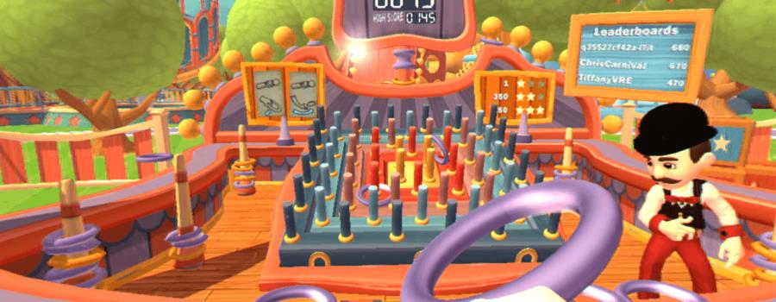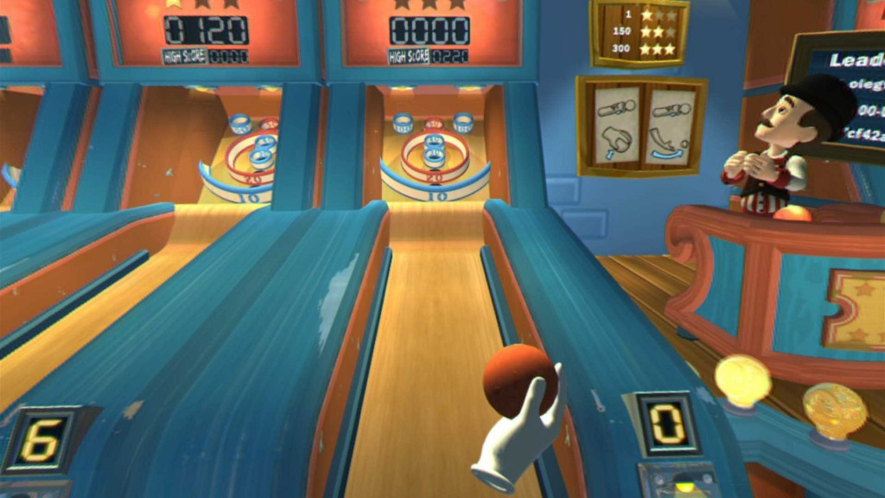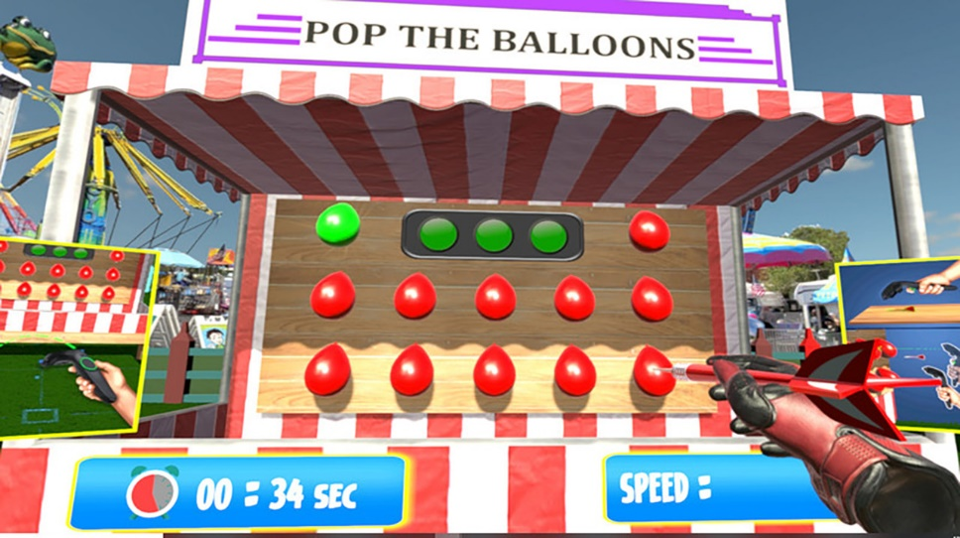

**UI**

Simple diegetic UI  
Table has a counter with two sets of numbers, first that contains highest score and next to it, the current score. (Imagery needed)

**Aesthetic**

* Arrow Types

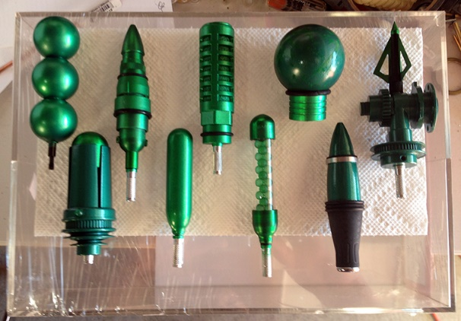

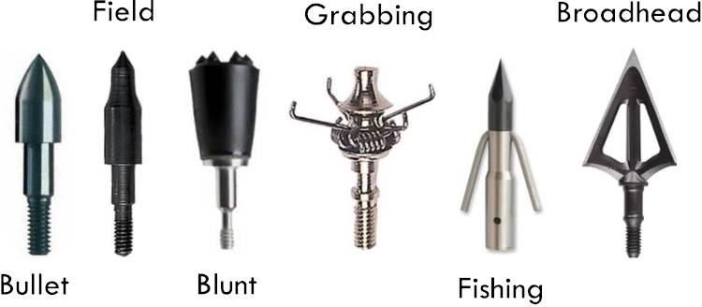

* Bow (Wooden)

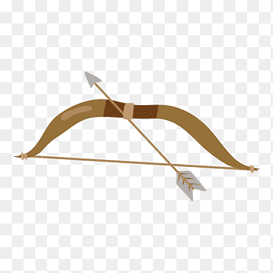

* Targets and Tracks

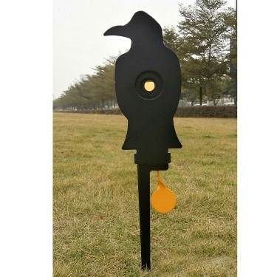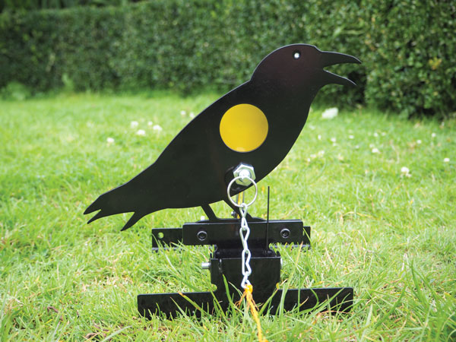

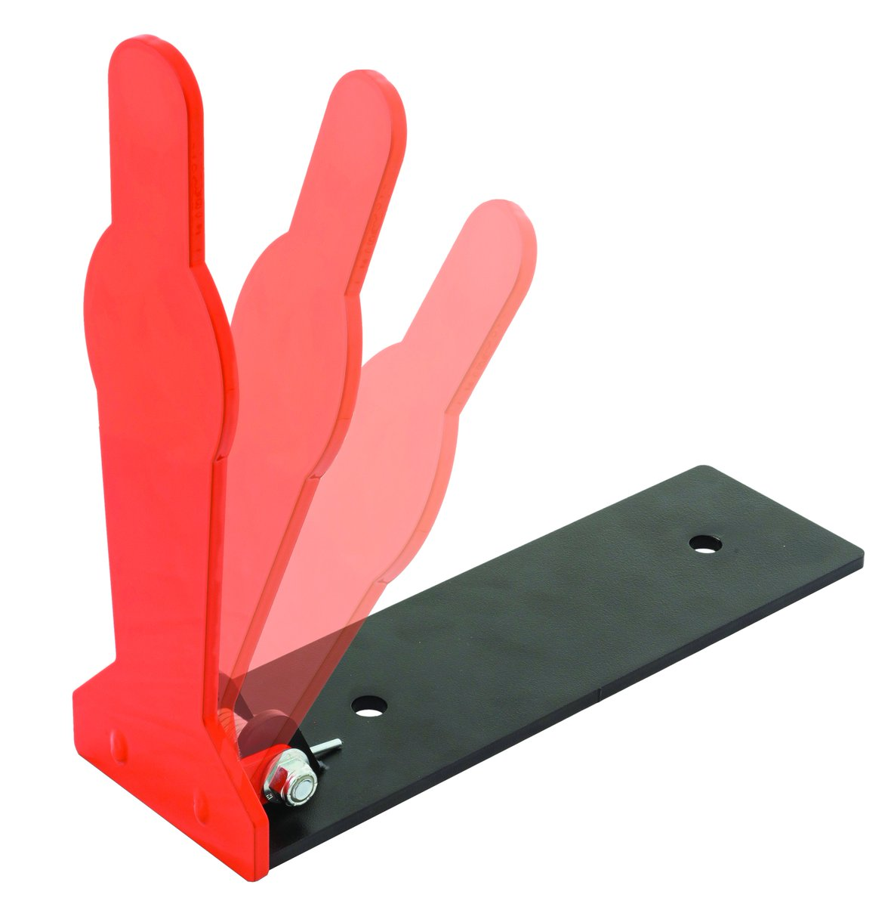 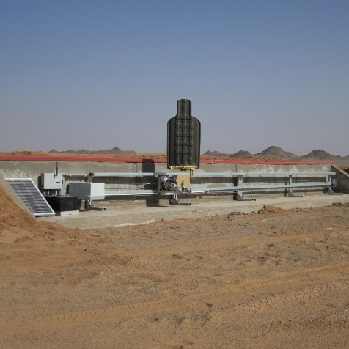

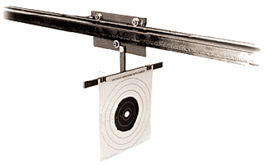

* Arrow, boxing glove, balloon, knife

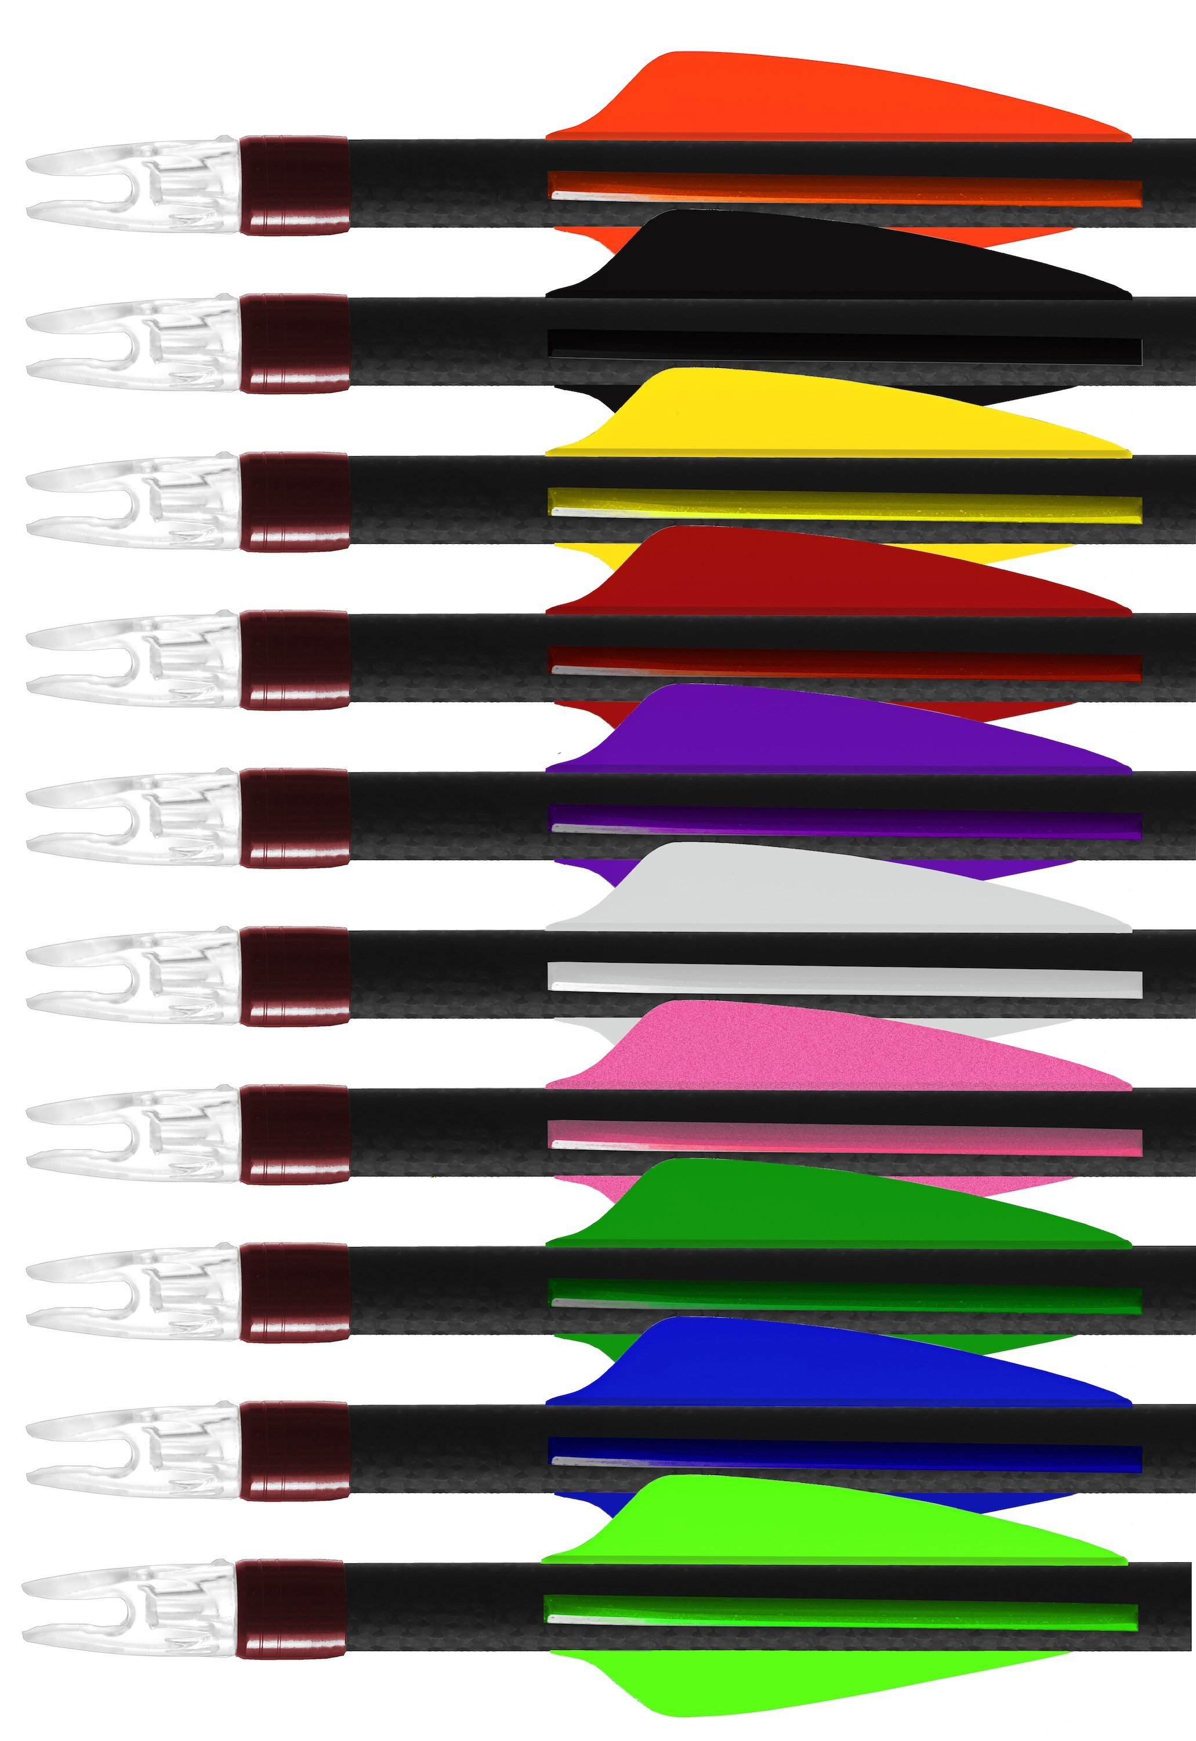

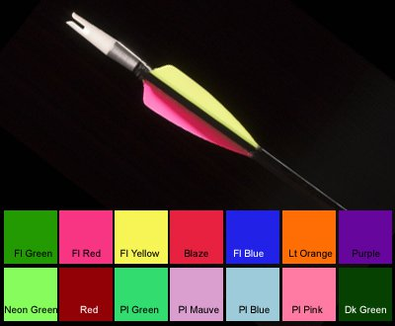

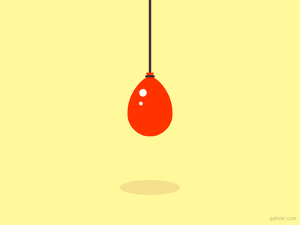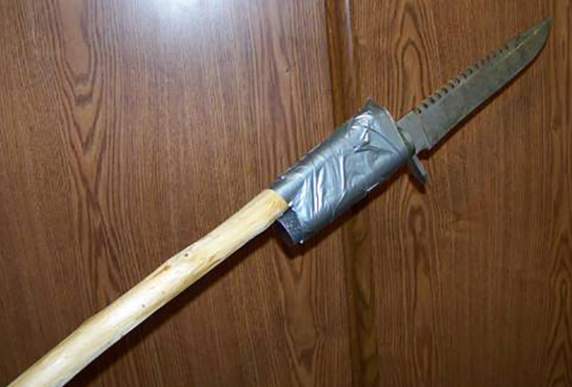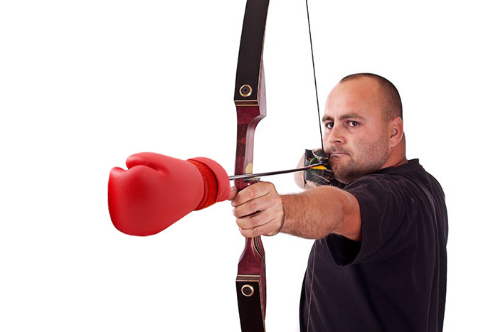

**Colour Palette**

* Wooden Bird

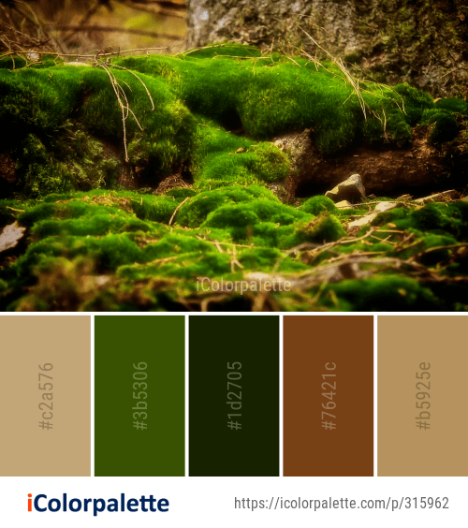

* Armoured Bird (Glass)



* Fire Bird

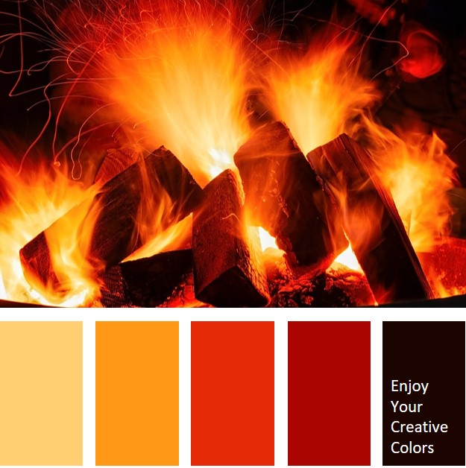

* Environment





* Barker

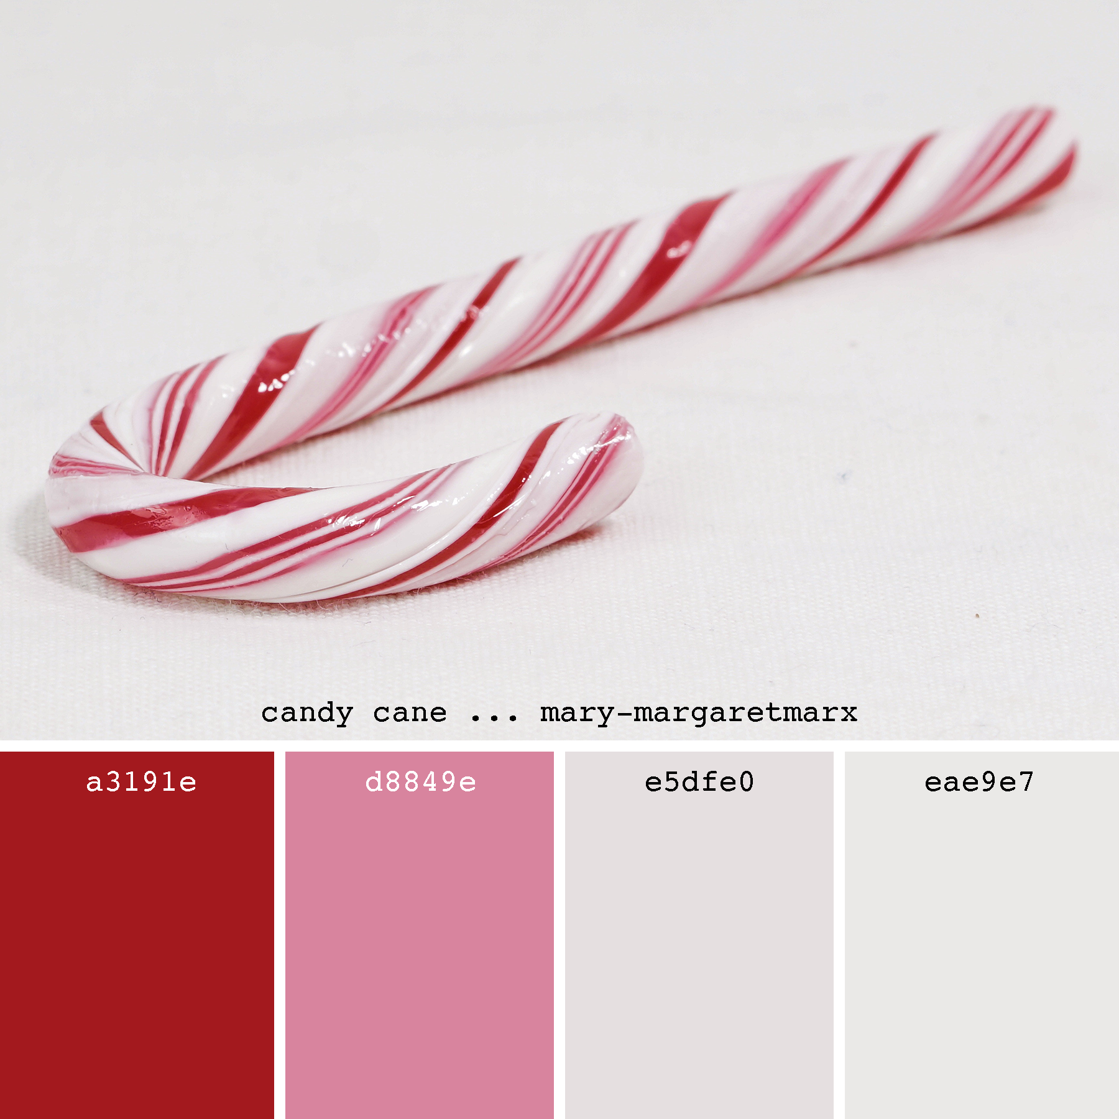

**Sound**

Spatial sound

* Origin of sounds should be tapered based on the distance of the sound from the player.
* Environmental
  + Wind
  + Rain
  + Turbine
  + Splatters
* Birds
  + Arm actuators
  + Impact sounds
    - Wood
    - Fire/quench/steam
    - Shatter/glass breaking
  + Rolling
* Bow
  + Twang/string
  + Creak wood tension
* Barker
  + Voice lines for everything
* Arrows
  + Individual pickup sounds
    - Splosh
    - Thump
    - Drawing a sword sound (schwing)
  + Sound in flight dependant on type (expansion bonus shit)
* Button
  + Button pressed sound
* Score Feedback
  + DING – positive
  + BOOBOO – Negative
  + Plug in barker here
* Voice Over
  + Barker
  + A lot of dialogue and sounds for and from the barker
* Music
  + Carnival/Circus style music

Order of dominance

* Other effects
  + Barker
    - Environmental
      * Music